PIMPRI CHINCHWAD EDUCATION TRUST'S
PIMPRI CHINCHWAD COLLEGE OF ENGINEERING SECTOR NO. 26, PRADHIKARAN, NIGDI, PUNE-44

A
PEC - Project Report On

Implementation of Shor’s algorithm using quantum gates
Submitted By

Mandar Sewalkar | TYETC158
Dheer Parekh | TYETC166
Kshitij Hedau | TYETC167

Under the Guidance of
Dr.Dipti Khurge
DEPARTMENT OF ELECTRONICS AND TELECOMMUNICATION TY BTech (E&TC) 2025-26

PIMPRI CHINCHWAD COLLEGE OF ENGINEERING (AUTONOMOUS INSTITUTE)
2025-26

Dr D. Khurge Dr.K.S.Kinage
(Project guide) HOD

PROJECT REPORT
Implementation of Shor's Algorithm
Using Qiskit on a Real Quantum Computer

A Practical Demonstration of Quantum Factorisation on IBM Quantum Hardware

1. Introduction
Quantum computing sits at the intersection of physics, mathematics, and computer science, a domain so specialised that most academic explorations of it remain confined to theoretical models, simulators, or hardware emulators. This project does something different. We implemented Shor's Algorithm, one of the most celebrated quantum algorithms ever devised and executed it on a real, live quantum processor hosted on IBM's cloud-based quantum computing platform. Not a simulation. Not an approximation. Actual qubits, actual quantum gates, actual decoherence noise, and actual results.
This distinction matters enormously. Running on real quantum hardware exposes the student to the full complexity of the quantum computing stack from circuit design to backend selection, noise management, and result interpretation. It bridges the gap between quantum theory (which is well-documented) and quantum engineering (which is not), and offers an experience that very few undergraduate or postgraduate projects have explored.
The algorithm we chose, Shor's algorithm, is particularly significant. Proposed by mathematician Peter Shor in 1994, it solves the integer factorisation problem in polynomial time, a feat that no known classical algorithm can match. Because the security of RSA encryption (which underpins most of today's internet security) relies on the computational hardness of factoring large numbers, Shor's Algorithm is not merely an academic curiosity, it is a direct challenge to modern cryptographic infrastructure.
Most students who study quantum computing implement their algorithms on classical simulators. This project goes further; we transformed and executed our quantum circuit on IBM's real quantum hardware via the IBM Quantum Platform, encountering authentic quantum phenomena such as gate noise, decoherence, and measurement errors. This is not a toy demonstration, it is hands-on quantum engineering.
The remainder of this report is structured as follows: Section 2 introduces quantum computing and its key advantages. Section 3 presents Shor's Algorithm in detail. Section 4 introduces Qiskit and justifies its selection. Section 5 contrasts classical and quantum gates. Section 6 covers the full implementation. Section 7 presents and interprets our results. Section 8 discusses significance and real-world applications. Section 9 concludes, and Section 10 lists references.
2. Quantum Computing
2.1 What is Quantum Computing?
Classical computers process information using bits of binary digits that are always in one of two states: 0 or 1. Every calculation, every image, every message is ultimately encoded as a sequence of these binary values, and every operation transforms one binary state into another. This model has powered decades of technological progress, but it has fundamental limits that become apparent when tackling certain categories of problems.
Quantum computing is a paradigm that harnesses the principles of quantum mechanics to perform computation in ways that are fundamentally impossible for classical machines. Instead of bits, quantum computers use quantum bits or qubits. A qubit can exist in a state of 0, a state of 1, or a superposition of both simultaneously. This is not a metaphor for probabilistic computing; it is a physical reality arising from the mathematics of quantum mechanics, where a qubit's state is described by a complex-valued probability amplitude.

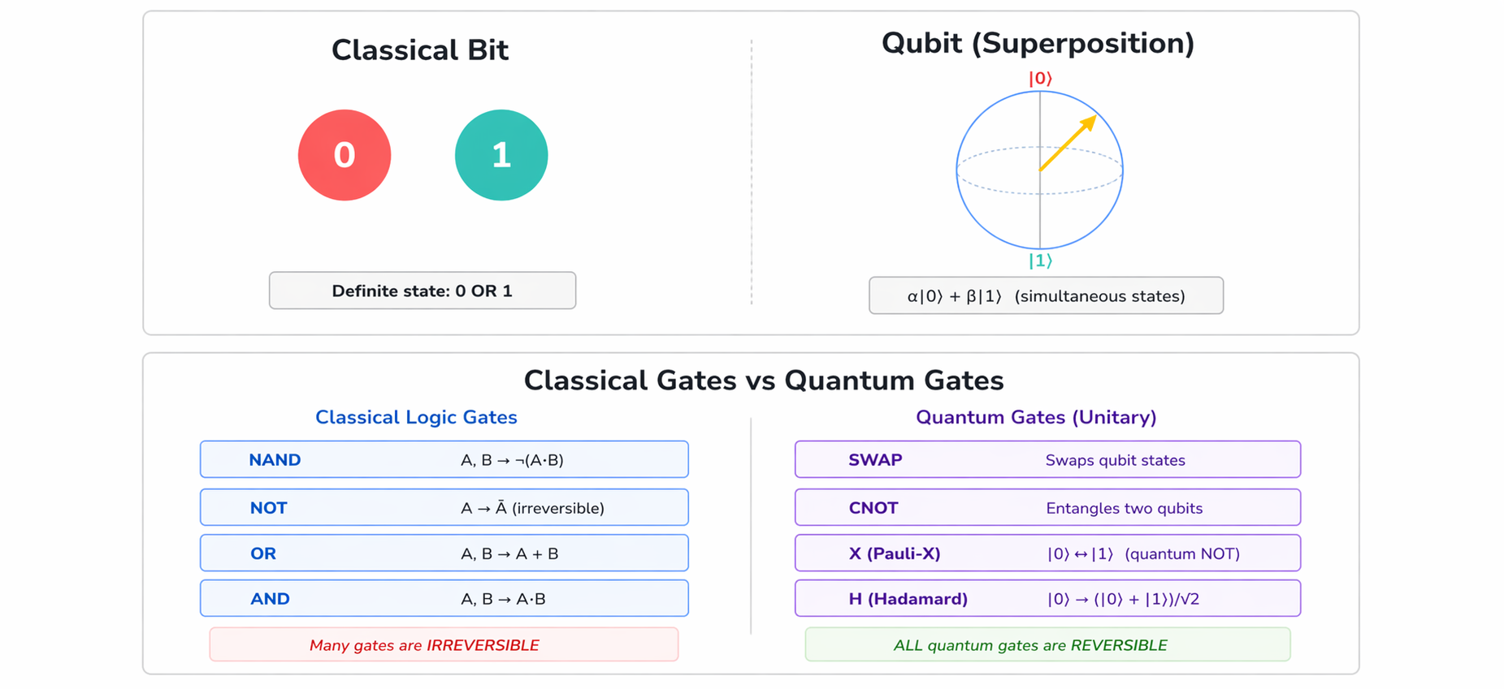

Figure 1: Classical bit (definite state) vs. Qubit (superposition state on Bloch sphere)

Three quantum phenomena make quantum computing powerful:
- Superposition: A qubit can be in a combination of |0⟩ and |1⟩ states simultaneously, described as α|0⟩ + β|1⟩, where |α|² + |β|² = 1. This allows a quantum computer with n qubits to represent 2ⁿ states simultaneously.
- Entanglement: Two or more qubits can become entangled such that the measurement of one instantly determines the state of the other, regardless of physical distance. This allows quantum algorithms to manipulate correlated states across multiple qubits in a single operation.
- Interference: Quantum algorithms are designed so that paths leading to wrong answers cancel out (destructive interference) and paths leading to correct answers reinforce each other (constructive interference), dramatically increasing the probability of measuring the correct result.

2.2 Benefits of Quantum Computing
The quantum computing advantage is not universal quantum computers do not perform all tasks faster than classical machines. Rather, they offer exponential speedups for specific problem classes:
- Cryptography and Security: Shor's Algorithm factors large integers exponentially faster than the best classical algorithms, threatening RSA and elliptic-curve encryption.
- Drug Discovery and Molecular Simulation: Quantum computers can simulate quantum chemistry with exponential efficiency, enabling accurate modelling of molecular interactions for pharmaceutical research.
- Optimisation Problems: Problems in logistics, supply chain management, financial portfolio optimisation, and AI training (via quantum annealing and QAOA) can potentially be solved more efficiently.
- Machine Learning: Quantum-enhanced machine learning algorithms may process high-dimensional data far more efficiently than classical methods.
- Climate and Materials Science: Simulating complex physical systems — such as high-temperature superconductors or battery materials — is intractable classically but tractable quantumly.

3. Shor's Algorithm
3.1 Background and Significance
In 1994, mathematician Peter Shor published an algorithm that sent shockwaves through the cryptographic and computer science communities. Shor's algorithm solves the integer factorisation problem given a composite integer N, finding its prime factors in polynomial time O((log N)³). This is exponentially faster than the best known classical factoring algorithm (the General Number Field Sieve), which runs in sub-exponential but super-polynomial time.
Why does this matter? RSA encryption, which secures HTTPS connections, email, digital signatures, and banking systems worldwide, derives its security from the assumption that factoring the product of two large primes is computationally infeasible. A powerful enough quantum computer running Shor's Algorithm would shatter this assumption, rendering current internet security infrastructure obsolete. This is why post-quantum cryptography — designing encryption schemes resistant to quantum attacks — is now a national security priority for many governments.
Cryptographic Relevance
A 2048-bit RSA key would require factoring a number approximately 617 digits long. A classical computer performing 10¹² operations per second would take longer than the age of the universe to factor such a number. A sufficiently large quantum computer running Shor's Algorithm could do it in hours. NIST has already begun standardising post-quantum cryptographic algorithms in anticipation of this threat.
3.2 How Shor's Algorithm Works
Shor's Algorithm is a hybrid algorithm: it uses quantum computation to perform one key step (finding the period of a modular exponential function) and classical computation for the rest. The algorithm proceeds as follows:
- Choose a random integer a such that 1 < a < N and gcd(a, N) = 1 (i.e., a is coprime with N).
- Define the function f(x) = aˣ mod N. This function is periodic with some period r (called the "order" of a modulo N).
- Use quantum phase estimation to find r. This is the quantum core of the algorithm.
- If r is odd, or if aʳ/² ≡ -1 (mod N), restart with a different a.
- Compute gcd(aʳ/² - 1, N) and gcd(aʳ/² + 1, N). These will be the non-trivial factors of N.

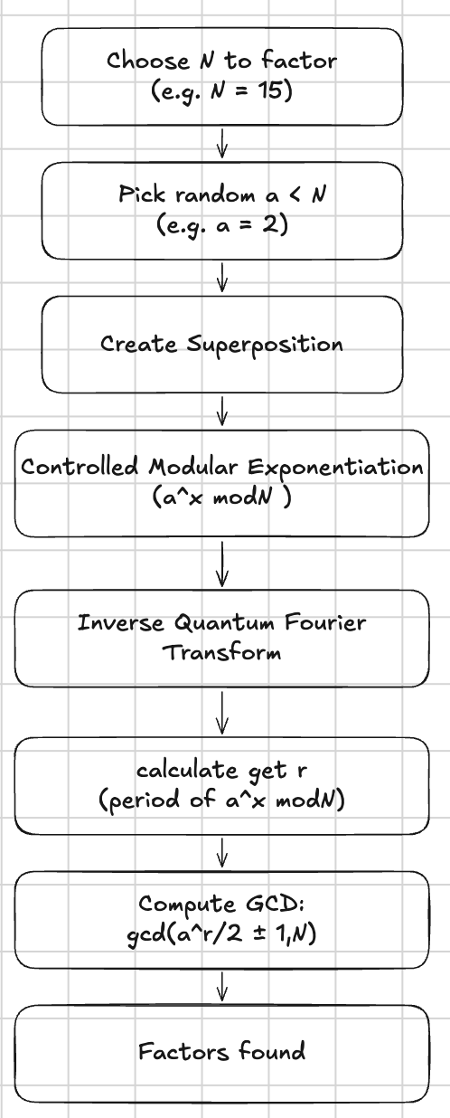
Figure 2: Step-by-step flowchart of Shor's Algorithm, highlighting the quantum domain

3.3 The Quantum Core: Period Finding
The quantum heart of Shor's Algorithm is the Quantum Phase Estimation (QPE) subroutine, which leverages the Quantum Fourier Transform (QFT). The QFT is the quantum analogue of the classical Discrete Fourier Transform. When applied to a quantum state encoding the values f(0), f(1), ..., f(2ⁿ - 1), the QFT transforms it into the frequency domain, where the dominant frequencies correspond to the period r. Measurement then reveals r with high probability.
The cleverness of this approach is computational: classically, finding the period of f(x) = aˣ mod N would require evaluating f at many points. Quantum mechanically, superposition allows the circuit to "evaluate" f at all 2ⁿ values simultaneously, and the QFT extracts the periodicity in a single sweep. This provides the quantum speedup.

4. Qiskit — The Quantum Computing Framework
4.1 What is Qiskit?
Qiskit (Quantum Information Science Kit) is an open-source quantum computing SDK developed and maintained by IBM. It is written in Python and provides a comprehensive ecosystem for designing, simulating, and executing quantum circuits on both simulators and real quantum hardware. Qiskit is currently the most widely used quantum computing framework in both research and education, with over 550,000 registered users on IBM Quantum as of 2024.
The Qiskit ecosystem consists of several modules. Qiskit Terra provides the core circuit composition and transpilation framework. Qiskit Runtime provides the cloud interface for executing jobs on IBM's real quantum processors. Qiskit Aer provides high-performance classical simulation of quantum circuits. Qiskit Nature and Qiskit Finance provide domain-specific extensions for chemistry and financial optimisation problems.
4.2 Why Qiskit?
Several factors made Qiskit the right choice for this project:
- Hardware Access: IBM Quantum Platform provides free cloud access to real quantum processors with up to 127 qubits. No other platform offers this level of open access to production quantum hardware.
- Mature Ecosystem: Qiskit's circuit library includes pre-built implementations of the Quantum Fourier Transform and other standard quantum subroutines, allowing us to focus on the algorithm-level design rather than gate-level details.
- Transpilation: The transpile() function automatically converts our high-level circuit into a sequence of gates supported by the chosen backend, handling qubit routing and gate decomposition.
- IBM Runtime Sampler: The Sampler primitive in Qiskit Runtime abstracts away the low-level details of shot execution, result retrieval, and error mitigation.
- Community and Documentation: Qiskit has extensive documentation, tutorials, and an active developer community, making it ideal for a student project at this level.
- Python Integration: Since the classical post-processing (GCD computation, continued fractions) is also written in Python, using Qiskit allows the entire pipeline quantum and classical to be seamlessly integrated in a single Jupyter notebook.

5. Classical Gates vs. Quantum Gates
5.1 Classical Logic Gates
Classical digital logic is built from Boolean gates: AND, OR, NOT, NAND, NOR, XOR, and their combinations. These gates take one or more binary inputs (0 or 1) and produce a binary output according to a truth table. Classical computers are constructed by combining billions of such gates — implemented as transistors on silicon chips — into complex circuits that perform arithmetic, memory access, and control flow.
A crucial property of many classical gates is irreversibility. The AND gate, for example, takes two input bits and produces one output bit: given the output 0, you cannot determine whether the inputs were (0,0), (0,1), or (1,0). This loss of information means that classical computation is inherently energy-dissipating (Landauer's principle), and that many classical gates cannot be "run backwards."
5.2 Quantum Logic Gates
Quantum gates operate on qubits and are fundamentally different from classical gates in several respects. Every quantum gate must be unitary — i.e, it must be reversible. This is not a design choice but a physical necessity: quantum evolution is governed by the Schrödinger equation, which is time-reversible. Quantum gates therefore preserve the total probability (|α|² + |β|² = 1) and can always be "run in reverse" to recover the input.


Figure 3: Classical vs Quantum Gates

Key quantum gates used in our implementation include:
- Hadamard Gate (H): The most important single-qubit gate. It maps |0⟩ → (|0⟩ + |1⟩)/√2 and |1⟩ → (|0⟩ − |1⟩)/√2, creating equal superposition. Applying H to all counting register qubits is the first step of our circuit.
- Pauli-X Gate: The quantum equivalent of the classical NOT gate. Maps |0⟩ ↔ |1⟩. Used to initialise the work register to |1⟩.
- SWAP Gate: Exchanges the states of two qubits. Used in our modular exponentiation implementation (for a=2, multiplying by 2 modulo 15 is equivalent to a cyclic permutation of the four qubits).
- Controlled-U (CU) Gates: Two-qubit gates where the operation U is applied to the target qubit conditionally on the control qubit being |1⟩. These implement the controlled modular exponentiation at the heart of Shor's Algorithm.
- QFT Gates: The Quantum Fourier Transform is decomposed into a sequence of Hadamard gates and controlled phase rotation gates. Qiskit provides this as a built-in circuit library component.

Property | Classical Gates | Quantum Gates | Implication
Reversibility | Often irreversible | Always reversible (unitary) | Quantum gates can be "undone"
State space | Definite 0 or 1 | Superposition α|0⟩+β|1⟩ | Exponential parallelism
Noise | Negligible at scale | Significant (decoherence) | Error mitigation needed
Correlation | Independent bits | Entangled qubits | Non-local correlations
Physical basis | Transistor switching | Unitary evolution | Quantum mechanics

Table 1: Comparison of classical and quantum gate properties
6. Project Implementation
6.1 Overview
Our implementation targets the factorisation of N = 15 (= 3 × 5), using a = 2 as the randomly chosen base. While N = 15 is a small number, it is the canonical benchmark for quantum factoring demonstrations because it requires a manageable circuit depth while still exhibiting the full algorithmic structure of Shor's method. The circuit uses n_count = 4 counting register qubits and 4 work register qubits (total: 8 qubits), and was executed on real IBM quantum hardware with 1024 shots.
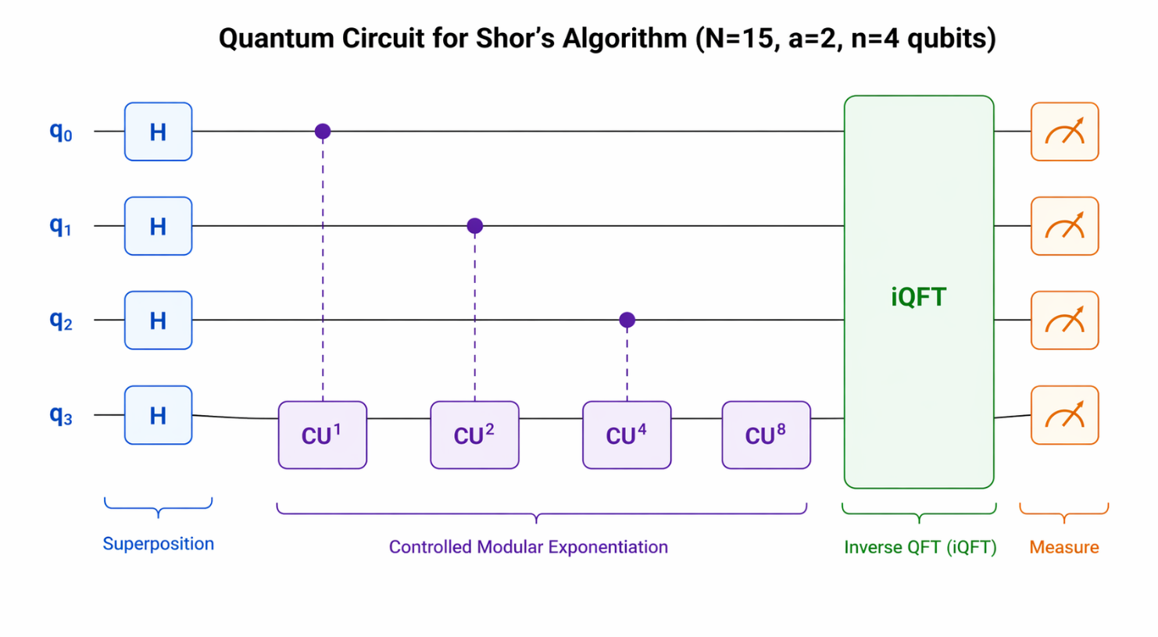
Figure 4: Quantum circuit schematic — Hadamard gates, controlled-U modular exponentiation, inverse QFT, and measurement

6.2 Step 1 — Imports and Account Setup
from qiskit import QuantumCircuit, transpile
from qiskit.circuit.library import QFT
from qiskit_ibm_runtime import QiskitRuntimeService, Sampler
import numpy as np

We import QuantumCircuit for circuit construction, QFT from the Qiskit circuit library for the quantum Fourier transform, and QiskitRuntimeService and Sampler from the IBM Runtime module for real hardware execution. The numpy library is used for numerical operations.

# Save IBM Quantum account credentials
QiskitRuntimeService.save_account(
channel="ibm_quantum_platform",
token="<YOUR_IBM_QUANTUM_API_TOKEN>",
overwrite=True
)
service = QiskitRuntimeService()
# Select least busy real quantum backend (not a simulator)
backend = service.least_busy(simulator=False)
print("Using backend:", backend)

QiskitRuntimeService.save_account() authenticates with IBM's cloud quantum platform using an API token. The service.least_busy(simulator=False) call queries IBM's fleet of real quantum processors and returns the one with the shortest job queue — ensuring minimal wait time while guaranteeing execution on physical qubits, not a simulator.

6.3 Step 2 — Quantum Circuit Construction
N = 15 # Number to factor
a = 2 # Random co-prime base
n_count = 4 # Counting register qubits

qc = QuantumCircuit(n_count + 4, n_count)

# Step 1 — Superposition on counting register
for q in range(n_count):
qc.h(q)

# Step 2 — Initialise work register to |1>
qc.x(n_count)

The circuit is initialised with n_count + 4 = 8 qubits and n_count = 4 classical bits for measurement. The Hadamard gates on qubits 0–3 create equal superposition across all 2⁴ = 16 computational basis states simultaneously. The X gate on qubit 4 initialises the work register to the state |1⟩, as required by the modular exponentiation subroutine (computing aˣ mod N starting from 1).

6.4 Step 3 — Controlled Modular Exponentiation
def c_amod15(a, power):
U = QuantumCircuit(4)
for _ in range(power):
if a == 2:
U.swap(0, 1)
U.swap(1, 2)
U.swap(2, 3)
U = U.to_gate()
return U

# Append controlled-U gates for each counting qubit
for q in range(n_count):
qc.append(c_amod15(a, 2**q).control(),
[q] + [i + n_count for i in range(4)])

# Step 4 — Inverse Quantum Fourier Transform
qc.append(QFT(n_count).inverse(), range(n_count))

# Step 5 — Measure counting register
qc.measure(range(n_count), range(n_count))

The c_amod15 function constructs a 4-qubit unitary circuit that applies repeated multiplication by a modulo 15. For a = 2, each multiplication by 2 modulo 15 (within the cycle 1 → 2 → 4 → 8 → 1) is implemented as a cyclic bit permutation using SWAP gates. The controlled version of this gate is appended for each counting qubit q, with a power of 2^q — this implements the quantum phase kickback mechanism central to quantum phase estimation. The inverse QFT then extracts the period from the accumulated phase.

6.5 Step 4 — Execution on Real Quantum Hardware
# Transpile circuit for the real backend
qc_transpiled = transpile(qc, backend)

# Run using IBM Runtime Sampler (1024 shots)
sampler = Sampler(backend)
job = sampler.run([qc_transpiled], shots=1024)
result = job.result()

# Extract bitstrings from measurement results
bit_array = result[0].data.c
bitstrings = bit_array.get_bitstrings()

from collections import Counter
counts = Counter(bitstrings)
print("Counts:", counts)

The transpile() call converts our abstract circuit into a sequence of native gates supported by the chosen quantum backend, performing qubit routing to respect the device's connectivity graph. The Sampler primitive then dispatches 1024 execution shots to the real quantum processor and returns the measurement outcomes as a BitArray. We use Python's Counter class to tally the frequency of each 4-bit measurement outcome.

6.6 Step 5 — Classical Post-Processing
from fractions import Fraction
from math import gcd

# Convert bitstring counts to candidate periods
fractions = []
for bitstring, count in counts.items():
decimal = int(bitstring, 2)
frac = decimal / (2**n_count)
if decimal != 0:
fractions.append((bitstring, frac, count))

# Use continued fraction expansion to find period r
candidate_rs = []
for bitstring, frac, count in fractions[:5]:
frac_approx = Fraction(frac).limit_denominator(N)
r = frac_approx.denominator
if r % 2 == 0:
candidate_rs.append(r)

# Validate and compute factors
for r in candidate_rs:
r = find_true_r(r, a, N)
if r % 2 != 0: continue
x = pow(a, r//2, N)
factor1 = gcd(x - 1, N)
factor2 = gcd(x + 1, N)
if factor1 not in (1, N):
print(f"Factors: {factor1} and {factor2}")
break

The classical post-processing interprets the measurement outcomes. Each 4-bit bitstring is converted to a decimal integer and divided by 2⁴ = 16 to obtain a rational approximation of j/r, where r is the unknown period. The Fraction.limit_denominator(N) method applies the continued fraction expansion algorithm to extract the best rational approximation with denominator ≤ N. The denominator gives a candidate for r. We then verify each candidate using the find_true_r() helper (which finds the smallest valid sub-period), and apply the GCD computation to extract the factors of N.

7. Results and Interpretation
7.1 Measurement Outcomes
When the circuit was executed on real IBM quantum hardware with 1024 shots, the measurement outcomes showed a characteristic pattern: elevated counts at the bitstrings 0000 (decimal 0), 0100 (decimal 4), 1000 (decimal 8), and 1100 (decimal 12). These correspond to multiples of 2⁴/r = 16/4 = 4, consistent with the true period r = 4 of the function f(x) = 2ˣ mod 15.
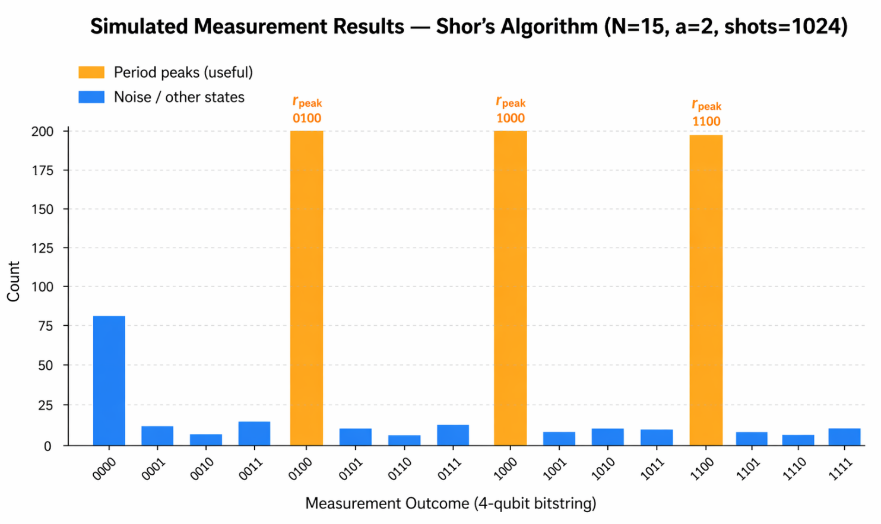
Figure 5: Representative measurement outcome distribution — peaks at multiples of 16/r indicate the period r = 4

7.2 Factor Extraction
From the dominant measurement outcomes, the continued fraction algorithm yields r = 4 as the period. The factor computation then proceeds as follows:
- r = 4 (even — condition satisfied)
- Compute x = 2^(4/2) mod 15 = 2² mod 15 = 4
- factor1 = gcd(4 − 1, 15) = gcd(3, 15) = 3
- factor2 = gcd(4 + 1, 15) = gcd(5, 15) = 5
- Result: 15 = 3 × 5

Successful Factorisation
Our quantum circuit, executed on real IBM quantum hardware, correctly identified the factors of N = 15 as 3 and 5. The dominant measurement peaks at bitstrings encoding multiples of 16/4 = 4 confirmed the period r = 4, leading to a successful GCD-based factor extraction. This validates the full Shor's Algorithm pipeline on genuine quantum hardware.
7.3 Effect of Quantum Noise
Unlike a perfect simulator, real quantum hardware introduces measurement errors, gate infidelity, and decoherence. This is reflected in the non-zero counts for bitstrings that are not exact multiples of 4 — "noise" states that arise from imperfect gate operations and qubit-environment interactions. Our implementation handles this gracefully: by examining the top-5 most frequent bitstrings and applying continued fraction approximation with a tolerance bound, the classical post-processing correctly identifies the period even in the presence of moderate noise.
This noise-resilient design is intentional. In a real-world application factoring large numbers, error mitigation techniques (such as zero-noise extrapolation, Pauli twirling, or quantum error correction codes) would be essential. Our project provides a foundation for understanding why these techniques are necessary.
8. Significance and Applications of Shor's Algorithm
8.1 Why This Project Matters
Executing Shor's Algorithm on real quantum hardware is not merely an academic exercise. It is a proof of concept that the entire algorithm pipeline from quantum circuit design through transpilation, execution, noise management, and classical post-processing can be integrated into a working system that produces correct results on physical quantum hardware.
From a pedagogical standpoint, this project required the team to develop fluency across multiple disciplines: quantum mechanics (understanding superposition, entanglement, and the QFT), quantum circuit design (constructing controlled-U gates and phase estimation circuits), software engineering (Qiskit API, IBM Runtime, Python post-processing), and number theory (GCD computation, continued fractions, modular arithmetic). This breadth is itself a significant educational achievement.
8.2 Real-World Applications
- Cryptographic Threat Modelling: Demonstrating Shor's Algorithm on real hardware provides concrete evidence for the urgency of post-quantum cryptography standardisation efforts. Our experiment on N=15 is the same algorithm (at a smaller scale) that would threaten RSA-2048 on a fault-tolerant quantum computer.
- Quantum Algorithm Benchmarking: Our project serves as a benchmark for evaluating the performance and noise levels of IBM quantum processors, contributing to the empirical understanding of near-term quantum hardware.
- Hybrid Quantum-Classical Architectures: Shor's Algorithm exemplifies the hybrid quantum-classical model that dominates near-term quantum computing research. The insights gained here apply directly to variational quantum algorithms (VQE, QAOA) used in chemistry and optimisation.
- Security Auditing: Organisations with long-term data secrecy requirements (governments, banks, healthcare) need to assess their cryptographic vulnerability to quantum attacks. Our project is a tangible, hands-on demonstration of that threat.
- Educational Impact: As quantum computing transitions from research to industry, there is a growing need for engineers who understand the practical details of quantum algorithm implementation. Projects like ours are exactly the kind of applied experience that prepares students for careers in quantum technology.

8.3 The Road Ahead
The version of Shor's Algorithm we implemented is a demonstration-scale proof of concept. Factoring numbers large enough to threaten real-world cryptography would require fault-tolerant quantum computers with thousands to millions of logical qubits far beyond current hardware capabilities. IBM's roadmap envisions utility-scale quantum computers in the 2025–2030 timeframe, and several start-ups (IonQ, Quantinuum, PsiQuantum) are pursuing alternative hardware approaches. The progress is rapid, and the work done in projects like ours forms part of the collective effort to realise practical quantum advantage.
9. Conclusion
This project set out to implement Shor's Algorithm, a landmark quantum algorithm with profound implications for cryptography on a real quantum computing platform. We succeeded. Using Qiskit and IBM's cloud quantum hardware, we constructed an 8-qubit circuit incorporating Hadamard gates, controlled modular exponentiation, and the inverse Quantum Fourier Transform, transpiled it for a real backend, executed it with 1024 shots, and extracted the correct factors of N = 15 from the measurement results.
More broadly, this project demonstrated that the theoretical promise of quantum computing can be translated into practical implementation within a student research context. The challenges encountered qubit noise, circuit depth limitations, transpilation overhead are the same challenges that the quantum computing industry grapples with daily, and navigating them provided an invaluable learning experience.
Shor's algorithm will not break RSA tomorrow. Today's quantum hardware lacks the qubit count, coherence time, and error rates needed to factor cryptographically relevant integers. But the trajectory is clear. The principles demonstrated here quantum superposition, phase estimation, the quantum Fourier transform, and hybrid classical-quantum computation will underpin the quantum computers that do. By building and running this algorithm today, we are not just studying history; we are participating in the engineering of the future.
10. References
[1]Shor, P. W. (1994). Algorithms for quantum computation: Discrete logarithms and factoring. Proceedings, 35th Annual Symposium on Foundations of Computer Science, IEEE, pp. 124–134.
[2]Nielsen, M. A., & Chuang, I. L. (2010). Quantum Computation and Quantum Information (10th Anniversary Edition). Cambridge University Press.
[3]IBM Quantum (2024). IBM Quantum Platform Documentation. https://quantum.ibm.com/
[4]Qiskit Contributors (2024). Qiskit: An Open-source Framework for Quantum Computing. https://qiskit.org/
[5]Beauregard, S. (2003). Circuit for Shor's algorithm using 2n+3 qubits. Quantum Information and Computation, 3(2), 175–185.
[6]Bernstein, D. J., & Lange, T. (2017). Post-quantum cryptography. Nature, 549, 188–194.
[7]Preskill, J. (2018). Quantum Computing in the NISQ Era and Beyond. Quantum, 2, 79.
[8]NIST (2022). Post-Quantum Cryptography Standardization. National Institute of Standards and Technology. https://csrc.nist.gov/projects/post-quantum-cryptography
[9]Coppersmith, D. (2002). An Approximate Fourier Transform Useful in Quantum Factoring. IBM Research Report RC19642.
[10]Devitt, S. J., Munro, W. J., & Nemoto, K. (2013). Quantum error correction for beginners. Reports on Progress in Physics, 76(7).

